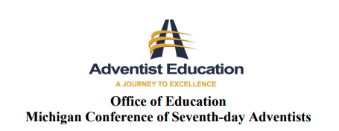
Special Education Awareness

_____(school name)____ has limited Special Education resources. Teachers implement accommodations and modifications for students within the school's ability to provide. Students applying for admission to _____(school name)____ from other schools, homeschool, or who are beginning their academic journey, who have an established IEP, 504, or are suspected of having needs (physical, mental, emotional, and behavioral) that impact their academic experience are required to provide copies of such documents during the enrollment application process.
______ My child does not have any special needs.
______ My child has needs in the following areas:
__ physical impairment __ hearing or visual impairment
__ ADHD __ Autism Spectrum Disorder __ learning disability
__ focusing &/or following instructions __exceptional learner
__ other: _______________________________________________
_______________________________________________
_____________________________ ___________________________________
Student Name Parent Signature & Date

The Individuals with Disabilities Education Act (IDEA) is a federal law providing resources and support to children. Students who are parentally placed in a non-public school are not afforded the same services as students in state-governed schools. Additional information is available in the school office and through the U.S. Department of Education/IDEA.

